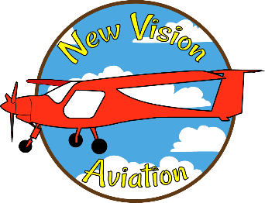

Membership Application

Date:

Name:

Address:

Best Contact Phone #:

Email Address:

U.S. Citizen (check one): Yes No

If “No”, please explain current status:

Age:

Parent Name and Approval Signature is Required for Membership If Under 18 years of Age:
Parent Name:

Parent Signature:

Do you possess a valid California Driver License (check one): Yes No

If “No”, when do you plan to acquire one?

Applicant Signature:

New Vision Aviation Board Approval Signature: Date

